ALI  HUSAIN  Bahraini Citizen  Email: Alij.saeed@gmail.com  Cell: 33322116 - 33374947 | To work in an esteemed organization that focuses on customers’ satisfaction and encourages new and rave ideas with the opportunity for continuous learning on a team spirit challenging environment. | 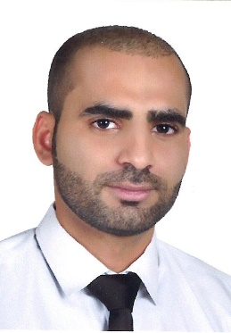

 | CAPABILITIES & SKILLS
- Well organized with experience of driving customers’ satisfaction and service.
- Business process management experience.
- Experience with quality system documentation and good documentation practices.
- Capability of following instructions, schedules, timelines and handle multiple tasks.
- Ability to utilize multiple word-processing & database applications including MS Office.
- Outstanding verbal and written communication skills.
- Fluent in English and Arabic languages.

PROFESSIONAL COURSES & QUALIFICATION
- Sales Assistant Training Course - Bahrain Duty Free.
- Program for Sales Assistant - Bahrain International Retail Development Centre.
- Business English Course - Delmon Academy.
- Developing Sales Skills - Al-Badeel Development
- Self Motivation - Al-Badeel Development
- Team Work - Logic Institute.

EXPERIENCE
      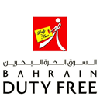  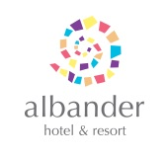 | Administrative Assistant October 2017– April 2018  IBG, International Business Group - Manama - Bahrain  - Purchase company requirements  - Send, receive and clear shipments  - Compiling and updating employee records (hard and soft copies)  - Assisting with day to day operations of the HR functions and duties  Communication Officer July/2013 – September 2017  Sofitel Bahrain - Zallaq, Bahrain  - Review arrival lists to welcome guests.  - Provide information about amenities, area and venues and promote services  - Anticipate guest needs and build rapport with customers  - Address customer complaints and escalate to Guest Relations Manager when needed  - Record information in the logbook daily  - Ensure compliance with health and quality standards  Sales Executive February/2011 – February/2012  OSN - Manama, Bahrain  - Assist to customer and product presentation.  - Communications with customers by telephone and emails.  - Arranging the site visit and measurement.  - Preparing the quotations and closing the sales.  - Follow-up with customer.  Sales Assistant July/2008 – August/2010  Bahrain Duty Free - Muhrraq, Bahrain  - Achieve a high level of customer satisfaction  - Reconcile & process cash and card payments.  - Advice & guide customers on product selections.  - Handling customers’ queries, complaints and feedback.  Operator December/2006 – May/2008  Al Bandar Hotel & Resort - Sitra, Bahrain  - Speaks clearly, and with a friendly, courteous tone.  - Uses listening skills to put callers at ease and obtains accurate, complete information.  - Takes and distributes messages for guests, provides information on guest services.  - Directs call to guest rooms, staff, or departments through the switchboard.  - Logs all wake-up call requests and performs wake-up call services.  EDUCATION
   |  | Bachelor of Business Informatics & Business Systems, (Withdrew)  AMA International University – Manama, Bahrain.  High School Certificate (Electrical Maintenance)  Al-Jabriya Secondary School - Manama, Bahrain.  REFERENCES

Will be provided upon request

